**Practical No. 7**

**Sharding Using MongoDB**

**Step 1: Create “data” folder inside that create “server1”, “server2”, “server3”.**

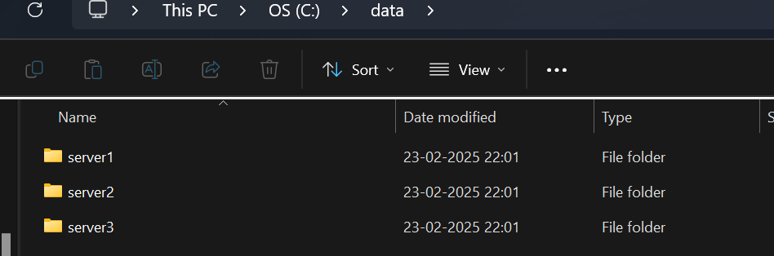

**Step 2: Initialize MongoDB Config Servers with configsvr and replSet options to form a Replica Set of Config Servers.**

Server 1

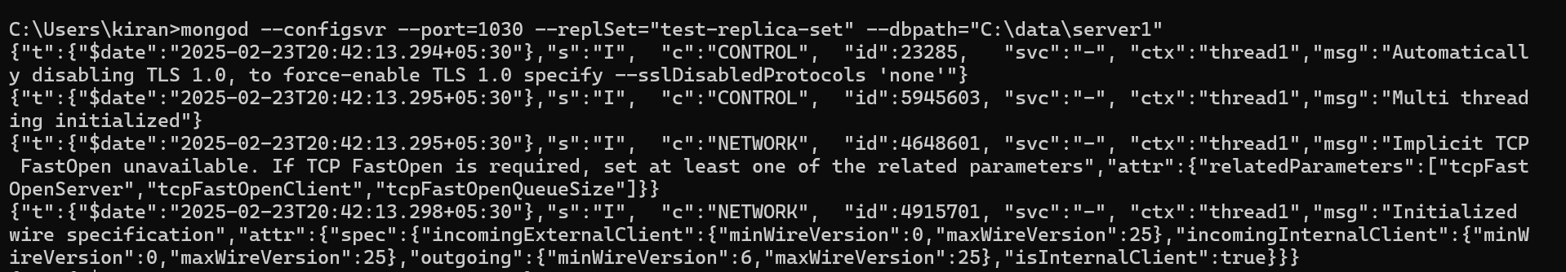

Server 2

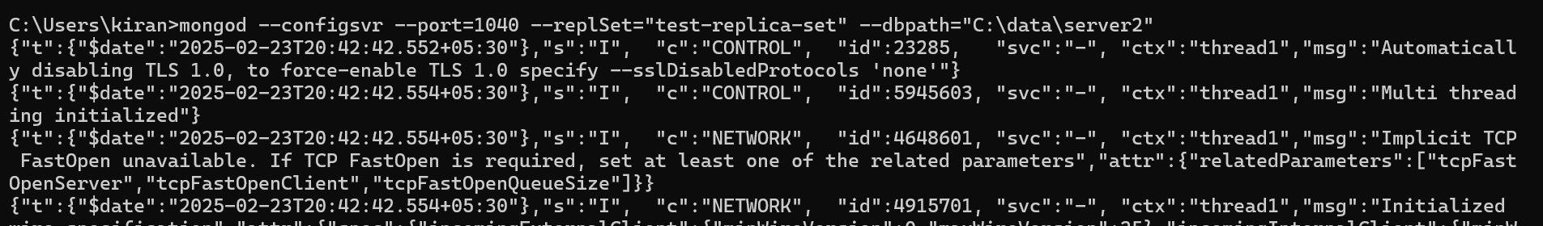

Server 3

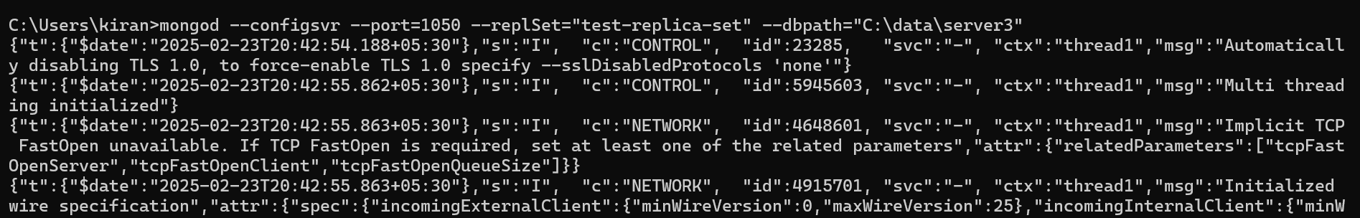

**Step 3: Connect to anyone of them using mongosh and Initiate Replica Set.**

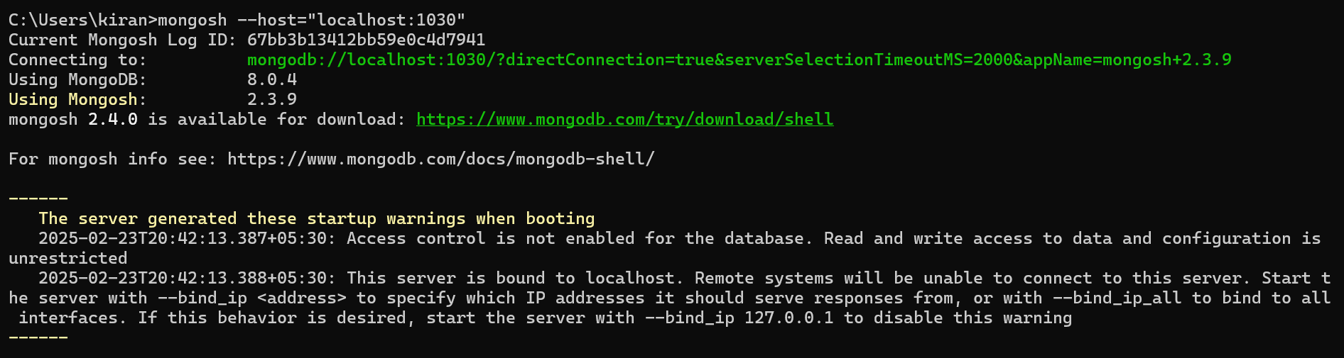

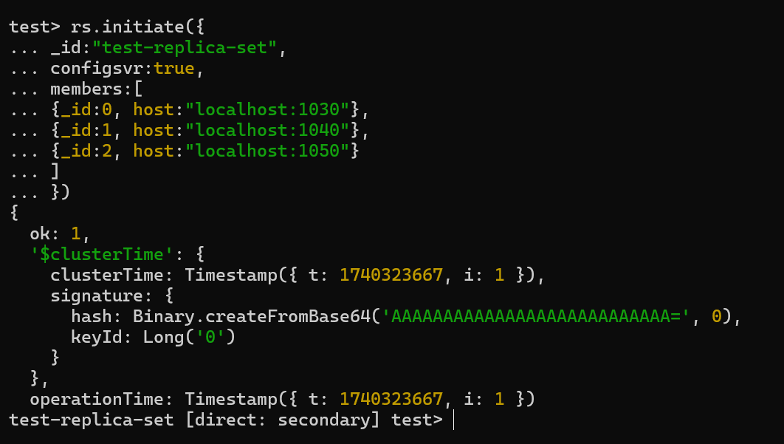

**Step 4: Create “shards” folder inside that create “shard1”, “shard2”, “shard3”.**

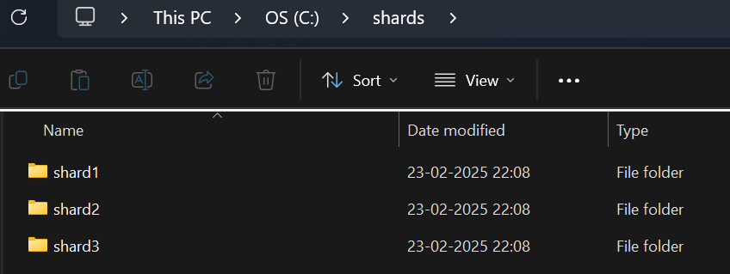

**Step 5:**

**Initialize MongoDB Shards**

Shard 1

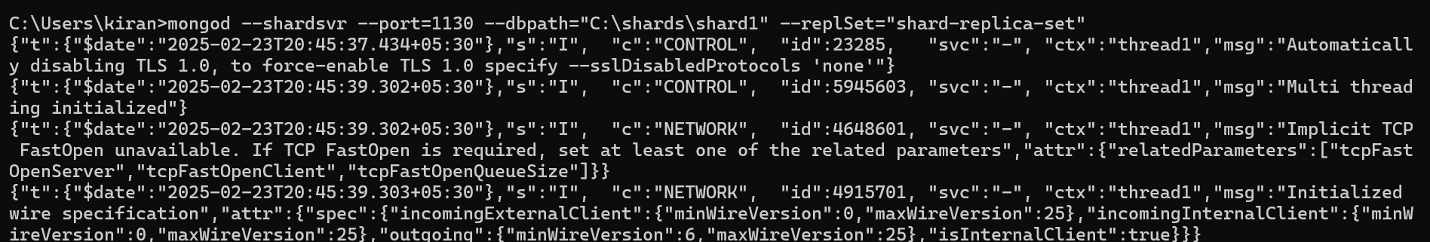

Shard 2

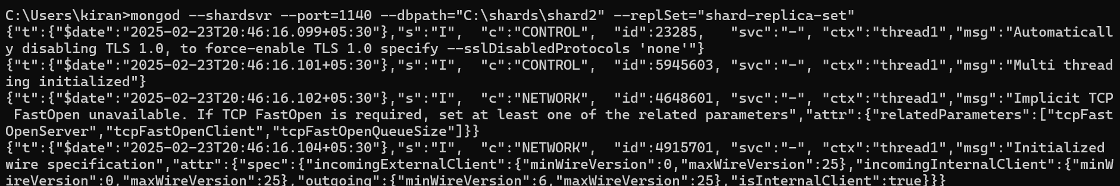

Shard 3

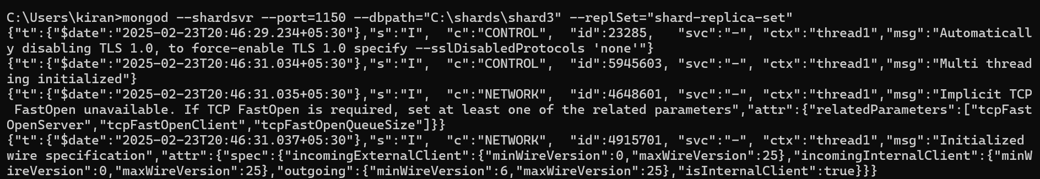

**Connect using mongosh**

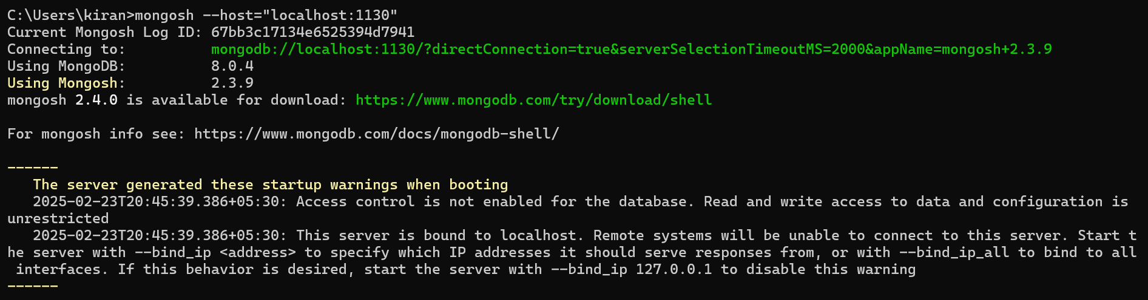

**Initiate Replica Set**

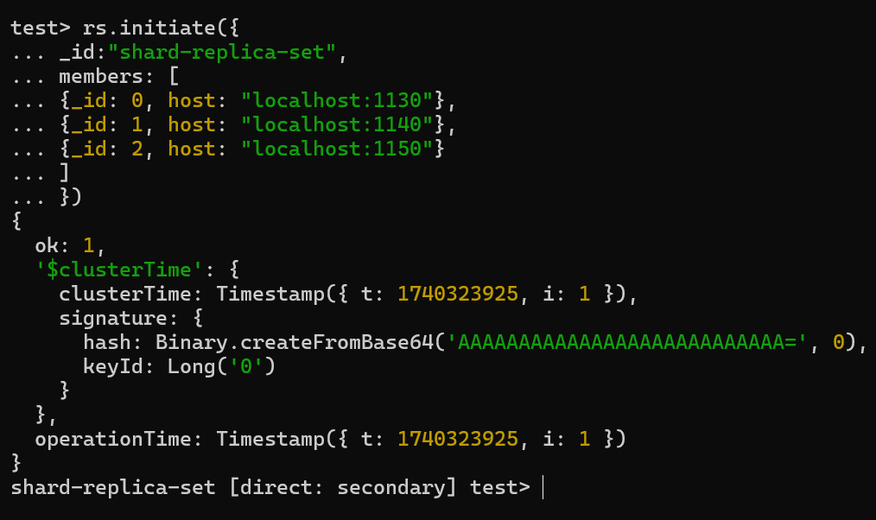

**Step 6:**

**Initialize a Query Router which is a mongos process.**

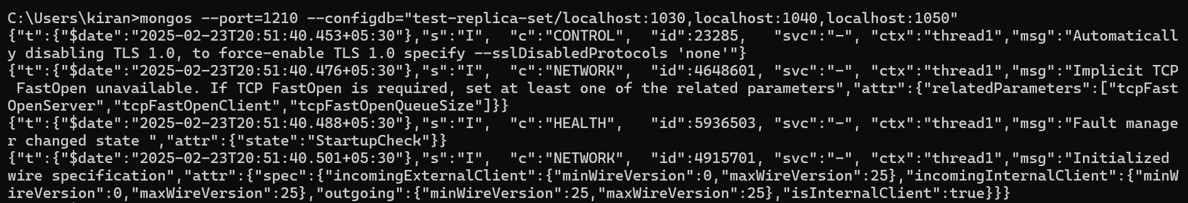

**Now, Connect Shards and Query Router (mongos)**

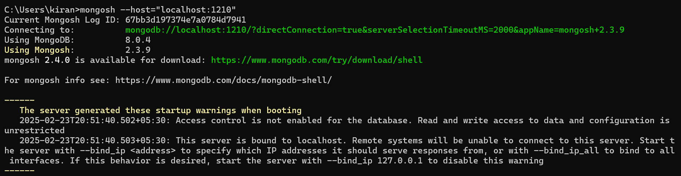

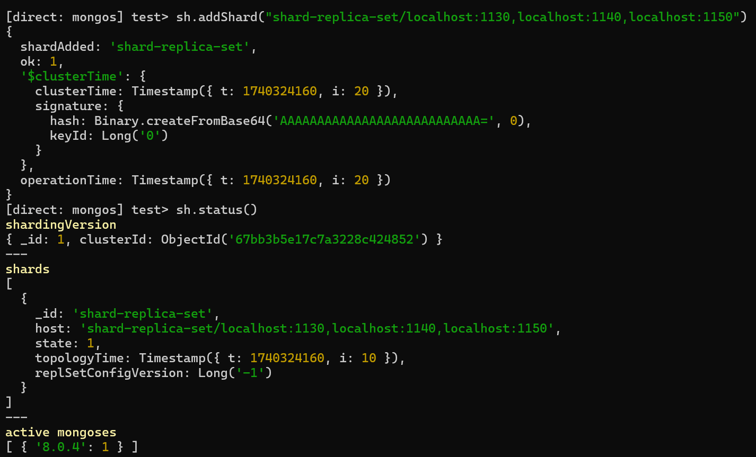

**Step 7:**

**Enable Sharding on a Specific Database of Shards Replica Set**

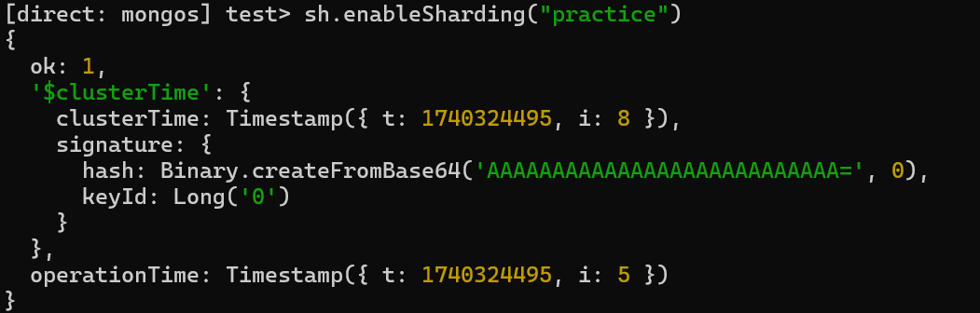

**Shard a Collection on the Sharding Enabled Database**

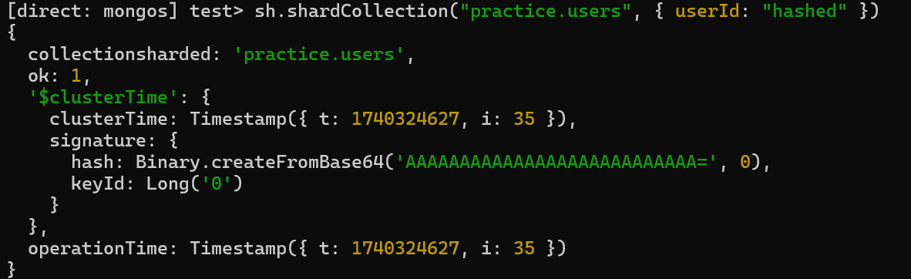

**Insert Sample Data and Verify**

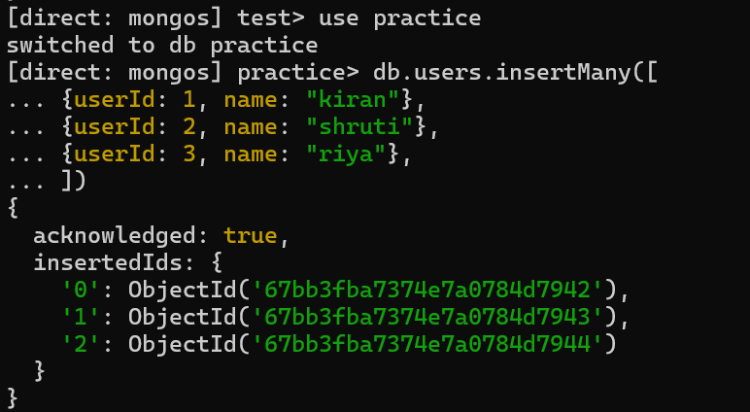

**Step 8:**

**To check where documents are stored**

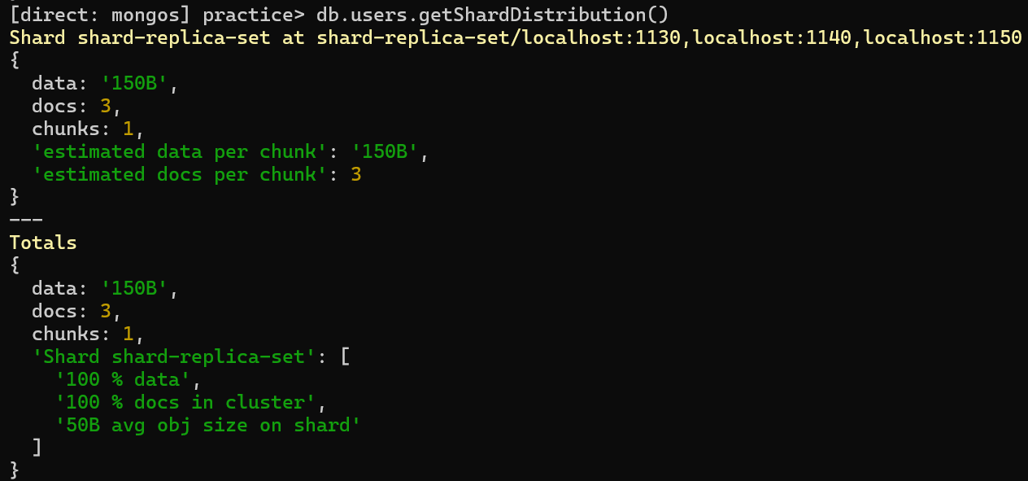

**To check collection-level sharding**

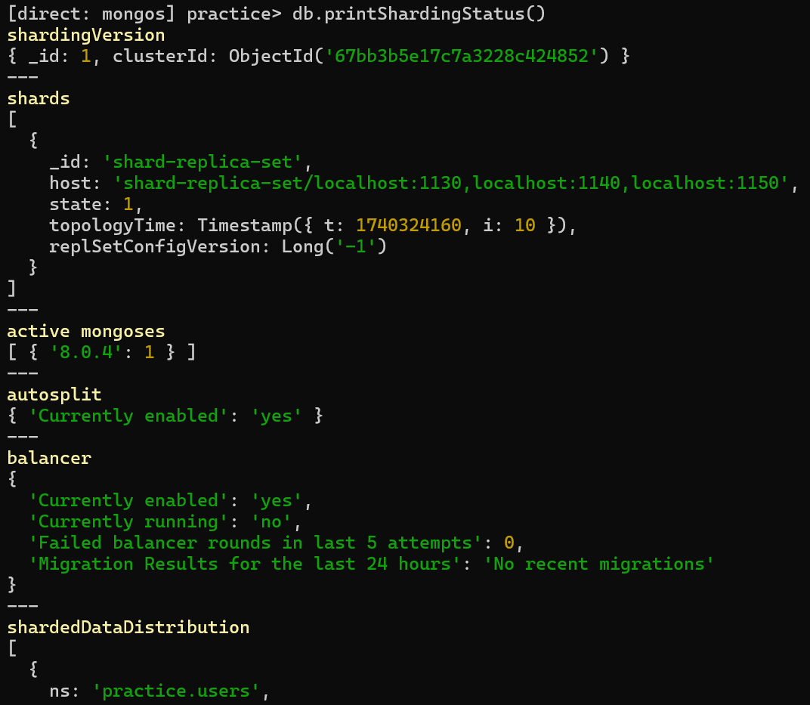

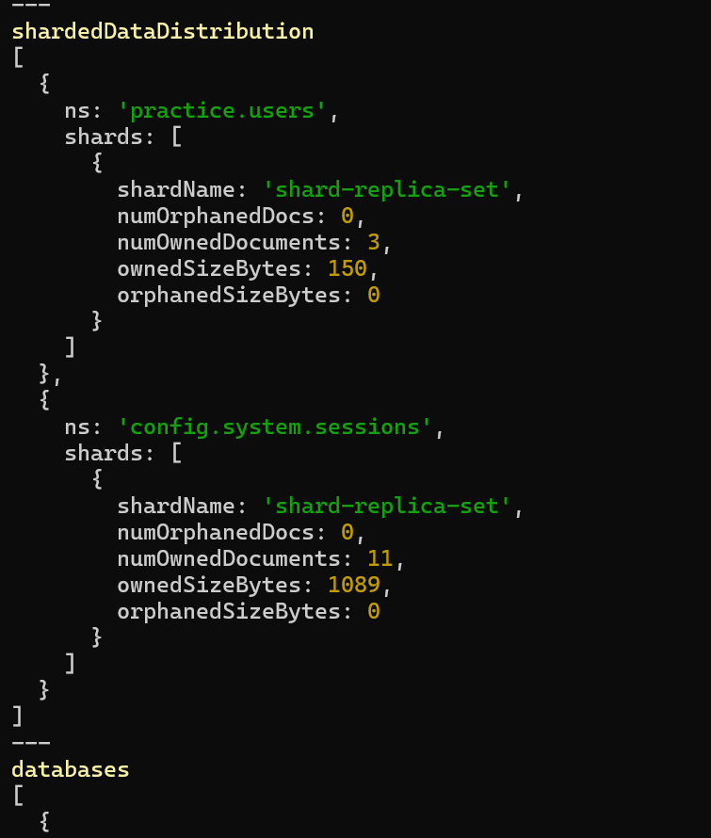

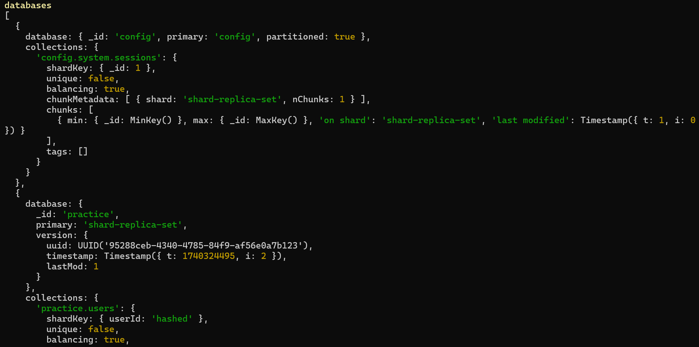

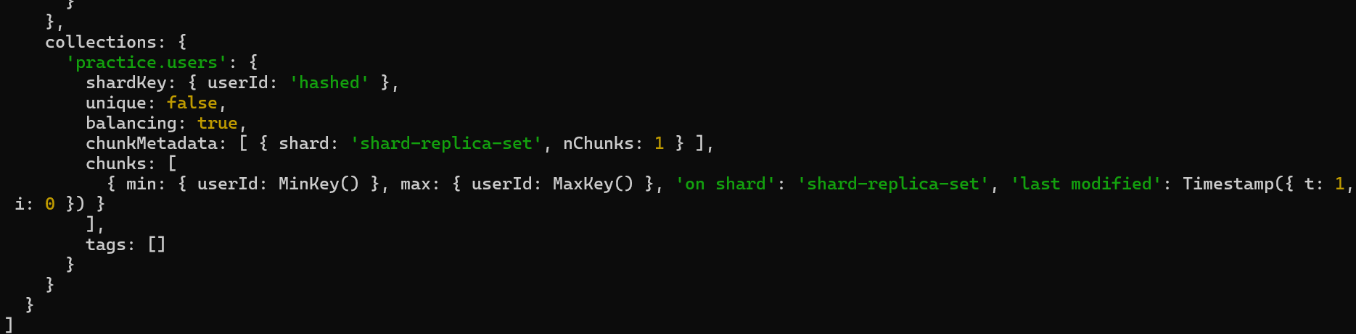

**To check overall cluster health**

